Date: 18.04.2025
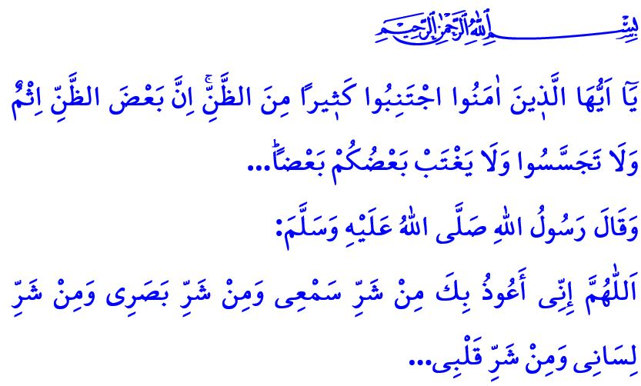SURAH AL-HUJURAT: BUILDING A SOCIETY OF VIRTUE
Honorable Muslims!
One of the surahs that governs the relationships between human beings and their Creator, with others, and with their environment, while introducing fundamental principles in this regard, is Surah al-Hujurat.
Surah al-Hujurat, also known as “the Surah of Morals”, teaches that people will only find honor through faith and attain true glory through Islam. It reminds the believers to remain united through the bond of faith, to uphold good manners, and to avoid all forms of words, attitudes, and behaviors that may harm their unity and solidarity.
Dear Believers!
Our Almighty Lord’s first message in Surah al-Hujurat is as follows: يَٓا اَيُّهَا الَّذ۪ينَ اٰمَنُوا لَا تُقَدِّمُوا بَيْنَ يَدَيِ اللّٰهِ وَرَسُولِهِ “O believers! Do not proceed ˹in any matter˺ before ˹a decree from˺ Allah and His Messenger...” Doing so means loving them more than anything else. It is to prioritize the pleasure of Allah and the love of our Prophet (saw) above all else. It is to remain devoted to the Qur’an and the Sunnah at all times and in all places. It is to regard the rulings of Allah and His Messenger as more important and more valuable than our own decisions, preferences, opinions, and thoughts. In short, not putting oneself before Allah and His Messenger is a binding command and a religious obligation for every believer.
Another message of Surah al-Hujurat is the command:اِنْ جَٓاءَكُمْ فَاسِقٌ بِنَبَأٍ۬ فَتَبَيَّنُٓوا يَٓا اَيُّهَا الَّذ۪ينَ اٰمَنُوا “O believers, if an evildoer brings you any news, verify ˹it˺...” The verse calls on us to be cautious of false news and misleading information. Because spreading false news, whether in real life or through digital media, and sharing unconfirmed information leads to mischief and discord among people, disrupting the atmosphere of peace and trust within society. It causes many people to become disconnected from life, results in the breakdown of many families, and leads to the dissolution of numerous friendships. We should never forget that sharing information and news whose accuracy we are unsure of is a great sin and a serious responsibility.
Esteemed Muslims!
Another message found in Surah al-Hujurat is the command:لَا يَسْخَرْ قَوْمٌ مِنْ قَوْمٍ يَٓا اَيُّهَا الَّذ۪ينَ اٰمَنُوا “O believers! Do not let some ˹men˺ ridicule others...” , وَلَا تَلْمِزُٓوا اَنْفُسَكُمْ وَلَا تَنَابَزُوا بِالْاَلْقَابِۜ “…Do not defame one another, nor call each other by offensive nicknames…” According to Islam, human beings are deserving of reverence and respect, and they must not be ridiculed, whether seriously or in jest, through actions, words, or even gestures such as the hand, tongue, eyebrow, or eye. A person’s honor must not be insulted, nor should they be called names that could harm their honor and dignity. The root of all these wrongs is pride and arrogance, which Allah never approves of; it is the inflated sense of self-importance and the contempt for others.
Another message in Surah al-Hujurat is the warning: “O believers! Avoid many suspicions, ˹for˺ indeed, some suspicions are sinful. And do not spy, nor backbite one another...” A believer is one from whom people are safe, both from the harm of their hand and the tongue. The believer always harbors goodwill towards others; they focus on their own faults, not the faults of others. The believer does not engage in backbiting, gossip, or spreading rumors.
Dear Believers!
Allah the Almighty addresses all humanity in Surah al-Hujurat as follows: “O humanity! Indeed, We created you from a male and a female, and made you into peoples and tribes so that you may ˹get to˺ know one another. Surely the most noble of you in the sight of Allah is the most righteous among you...” Our sublime religion, Islam, forbids all forms of racism. Yet today, the oppressors, who consider themselves civilized and distinguished, yet have no true share of humanity, feeding on savagery, inflict all kinds of cruelty, torture, and oppression on Muslims in Palestine, Gaza, and many other places. Allah the Almighty explains what the Ummah of Muhammad must do in order to put an end to all these evils in Surah al-Hujurat as follows: “The ˹true˺ believers are only those who believe in Allah and His Messenger—never doubting—and strive with their wealth and their lives in the cause of Allah. They are the ones true in faith.”
May our Almighty Lord grant us the ability to implement the truths described in Surah al-Hujurat in our lives, and to stay away from all the evils that corrupt our minds, hearts, and tongues, thus preserving our peaceful coexistence.

I would like to conclude this Friday’s khutbah with the following supplication of our Prophet (saw): “O Allah! I seek refuge in You from the evil of my ear, the evil of my eye, the evil of my tongue, and the evil of my heart...”

Hujurat, 49/1.
Hujurat, 49/6.
Hujurat, 49/11.
Hujurat, 49/12.
Hujurat, 49/13.
Hujurat, 49/15.
Tirmidhi, Da‘awat, 74. General Directorate of Religious Services

